https://towardsdatascience.com/cross-entropy-negative-log-likelihood-and-all-that-jazz-47a95bd2e81

NLLLoss :

Come from, appplying the log, max log likelihhod = minimizing the negative

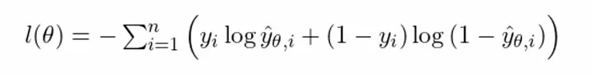
Multiclass :

With (y_{i}) means we only look at the true class. Beeing maximum mean be the closest to 1

but such (y^^_\theta ,i ) give a prediction, we can’t use a simple « sigmoid », so we use softmax which is strictly equivalent when C=2 to sigmoid

Cross entropy :

So the same but adding some weight ?

In Pytorch, Crossentropy is NLLLoss with softmax (so NO MORE SOFTMAX)

